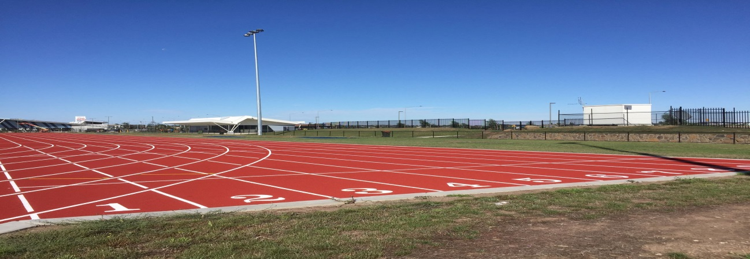
HUME CITY COUNCIL ABN: 14-854-354-856
SPRINT ATHLETICS TRACK APPLICATION FOR HIRE 2020
LEISURE CENTRES & SPORT Tel: 9205 2464

HIRER CONTACT INFORMATION
NAME OF SCHOOL/CLUB:
CONTACT NAME:
POSITION:
POSTAL ADDRESS/BILLING ADDRESS:

POSTCODE:
PHONE: | MOBILE:
EMAIL:

BOOKING REQUIREMENTS
AREA e.g. track, pits | DATE OF HIRE | TIME OF HIRE | EQUIPMENT REQ’D
- Yes (equipment hire form required)
- No
- Yes (equipment hire form required)
- No
- Yes (equipment hire form required)
- No
- Yes (equipment hire form required)
- No

INFORMATION PRIVACY ACT
Council is collecting the information on this form for the purpose of registering your application for the use of a Hume Leisure facility. The information may also be used to send you newsletters and other relevant Council information. The information will not be disclosed except as required by law. In particular, the information will not be disclosed to others for marketing purposes. If you fail to provide this information, your application may not be processed. You may access this information at any time by contacting Hume City Council on 9205 2200.

INSURANCE
It is a requirement of Council that all organisations are incorporated and have Public Liability Insurance. Please provide the following details for your Public Liability Insurance and enclose a copy with this application.

INSURANCE COMPANY:
POLICY NUMBER:
DATE: | AMOUNT:

DECLARATION

I _________________________________ as a delegate of _____________________________
Hereby agree to comply with all the Condition of Hire, a copy of which I have received, together with any additional Conditions of Hire as may be set by the Chief Executive Officer, and accept responsibility for the facility, it’s equipment, and those participating in the activities I have outlined on my hire form, for the duration of my hire.
Signature: ____________________________________ Date: ___________________________

PAYMENT DETAILS

CHARGE CATEGORY | RATE OF HIRE | INVOICE RAISED | DATE | STAFF SIGN
LOCAL SCHOOL | $55 per hour
NON LOCAL SCHOOL | $88 per hour
CASUAL | $132.00 per hour
ATHLETICS COACHING | $55.00 per hour
LIGHTING | $22.00 per hour
EQUIPMENT | $110.00

