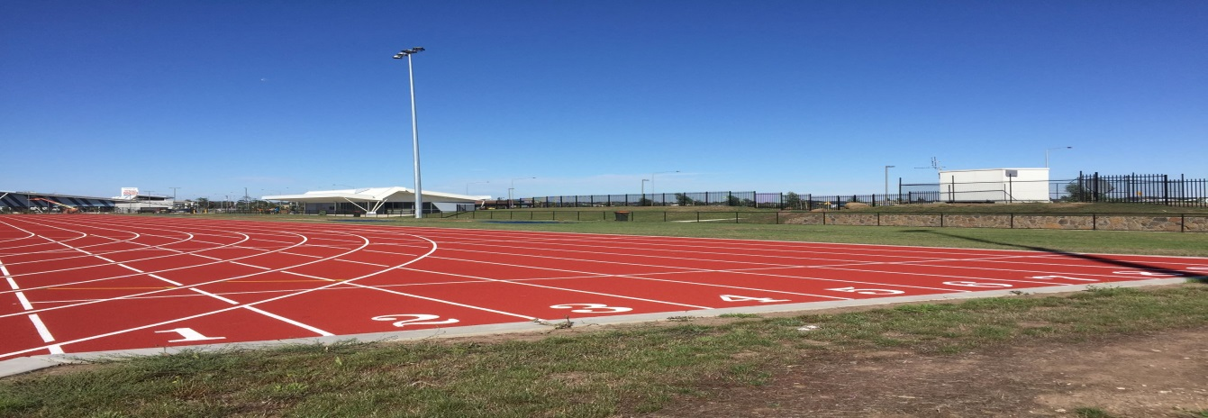
HUME CITY COUNCIL ABN: 14-854-354-856
SPRINT ATHLETICS TRACK EQUIPMENT HIRE 2020
LEISURE CENTRES & SPORTS Tel: 9205 2464

CONTACT INFORMATION
ORGANISATION:
CONTACT NAME:
DATE OF HIRE:

EQUIPMENT REQUIREMENTS (INCLUDES SET UP/PACK UP)
 | Required
ITEM | YES | NO |  | HOW MANY? | HEIGHT/WEIGHTS REQUIRED
SPRINTS
LONG DISTANCE
HURDLES
HIGH JUMP
LONG JUMP
TRIPLE JUMP
DISCUS

SHOT PUT

JAVELIN
HAMMER THROW

LIGHTING
CANTEEN FACILITIES
*food trucks available upon request

