



What to expect at (Glitter)

Hume City Council Youth Services

Plain English

Page 1 of 5

What to expect before joining the program


To join a session, book your place using the link on the Youth Services website.


A Youth Services staff member may contact your parent or guardian to see if you need any extra support.


Please speak with us before the session if you need your carer to attend the program with you.

What to expect during the program


Once you enter the program space your parent or guardian will say goodbye to you at the door.


Youth Services Staff and Omnia Community Health staff will say hello. Youth Services staff wear a blue lanyard around our neck or a black t-shirt or jumper that says ‘Hume Youth Services’.


When you enter the Youth Centre, there is an attendance sheet to write your name and the time you arrive.


If it is your first time, we will show you around the youth centre, the activity options, and centre guidelines.

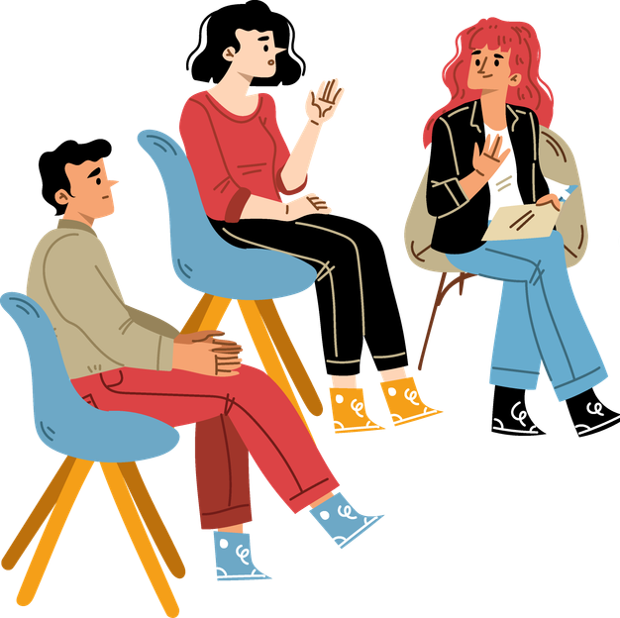
Other young people will be at the program. You can ask us how many other people will be there.


You can get a snack or a drink from the table. We ask that you do not share food you bring to keep others safe from allergies.


At the start, you can choose to join the group check in. You can share your name, pronouns and answer the get to know you question asked by us.

You may hear music or smell food. It can get loud at times.


You can talk to us if you need a quieter space or a prayer space.


You can join a planned activity if you want to. You can also use the space to relax, draw, play board games, table tennis, pool, or use a computer.

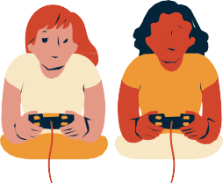
You can ask another young person or us to talk or do an activity with you.


It is okay if you do not want to talk or play with someone else.


We may ask how you are and talk about your week. You can choose what you want to share.


You can talk to us about
- School;
- Work;
- Mental Health;
- Support;
- Share how you feel bout the program



We will listen to each other and take turns. Sometimes we may move on so everyone can share our time.


You can leave the program whenever you want, as long as your parent or guardian has said it's okay and you let someone know before you go.


When you leave the Youth Centre, there is an attendance sheet to write your name and the time you leave.

More information
For more information contact Hume Youth Services. Website www.hume.vic.gov.au/Community -Services/Youth
Email youth@hume.vic.gov.au Phone (03) 9205 2556

