



What to expect at (Rainbow Lorikeet Collective)

Hume City Council Youth Services

Plain English

Page 1 of 6

What to expect before joining the program


Fill in an online expression of interest form to tell us about your connection to Hume and why you would like to join the program. You can ask us if you need a paper copy.


A Youth Services staff member will read your form and give you a call. We will talk about your interest in the program and any support you may need.


Please speak with us before the session if you need your carer to attend the program with you.

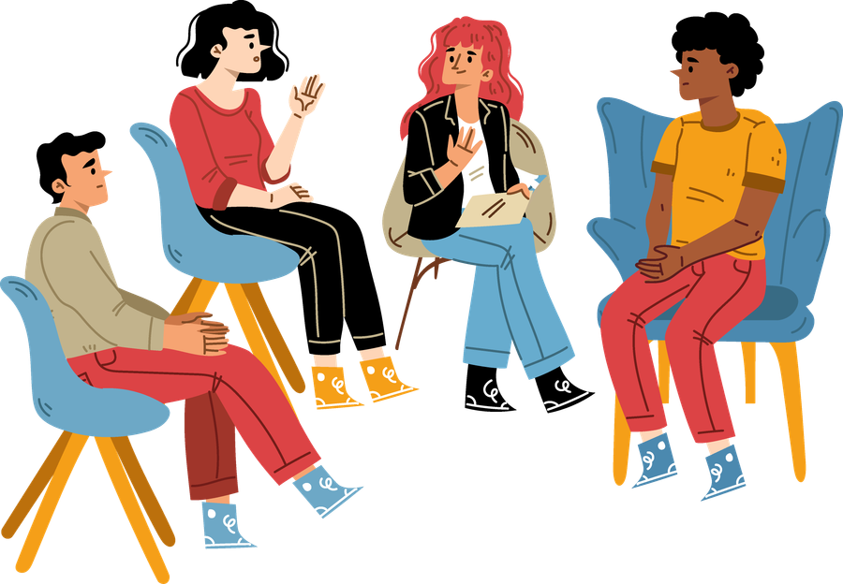
You can try the program before deciding to join as a participant.

If you would like to continue to join the program, you will need to complete a participation form and send it back to us. This form asks questions that help us support you while you attend the program.

What to expect during the program


Youth Services Staff and Omnia Community Health staff will say hello. Youth Services staff wear a blue lanyard around our neck or a black t-shirt or jumper that says ‘Hume Youth Services’.


When you enter the Youth Centre, there is an attendance sheet to write your name and the time you arrive.


If it is your first time, we will show you around the youth centre, the activity options, and centre guidelines.

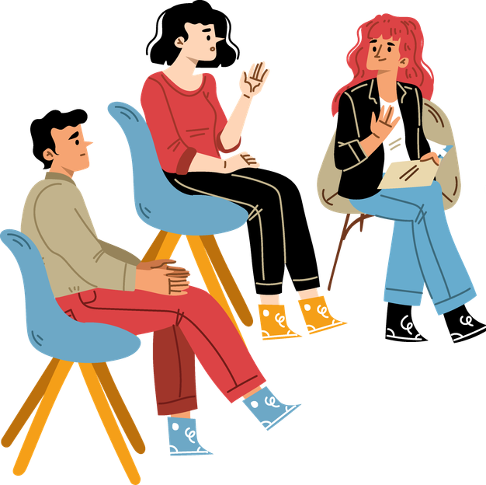
Other young people will be at the program. You can ask us how many other people will be there.


You can get a snack or a drink from the table. We ask that you do not share food you bring to keep others safe from allergies.

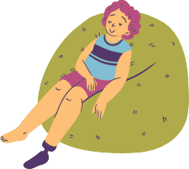
At the start, you can choose to join the group check in. You can share your name, pronouns and answer the get to know you question asked by us.

You may hear music or smell food. It can get loud at times.


You can talk to us if you need a quieter space or a prayer space.


You can join a planned activity if you want to. You can also use the space to relax, draw, play board games, table tennis, pool, or use a computer.

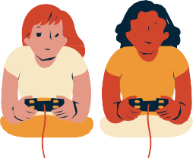
You can ask another young person or us to talk or do an activity with you.


It is okay if you do not want to talk or play with someone else.


We may ask how you are and talk about your week. You can choose what you want to share.


You can talk to us about
- School;
- Work;
- Mental Health;
- Support;
- Share how you feel bout the program



We will listen to each other and take turns. Sometimes we may move on so everyone can share our time.


You can leave the program whenever you want, you will let us know before you go.


When you leave the Youth Centre, there is an attendance sheet to write your name and the time you leave.

More information
For more information contact Hume Youth Services. Website www.hume.vic.gov.au/Community -Services/Youth
Email youth@hume.vic.gov.au Phone (03) 9205 2556

